

**Green University of Bangladesh**

**Department of Computer Science and Engineering (CSE) Faculty of Sciences and Engineering**

**Semester: (Fall, Year:2024), B.Sc. in CSE (Day)**

**KSA 2**

**Course Title: Differential Equations and Coordinate Geometry Course Code: MAT 201 ; Section: 232 D5**

**Student Details**

|  |  |  |
| --- | --- | --- |
| **Name** | | **ID** |
| **1.** | **Rukonuzzaman Topu** | **232002280** |

**Course Teacher’s Name: Shamima Islam**

**[For Teachers use only: Don’t Write Anything inside this box]**

**Assignment Report Status**

**Marks: …………………………………**

**Comments: ..............................................**

**Signature: .....................**

**Date: ..............................**

# Problem 1

## The population of a city increases at a rate proportional to the present number. It has an initial population of 80000 that increases by 35% in 13 years. What will be the population in 50 years?

* **Hand Calculation:**

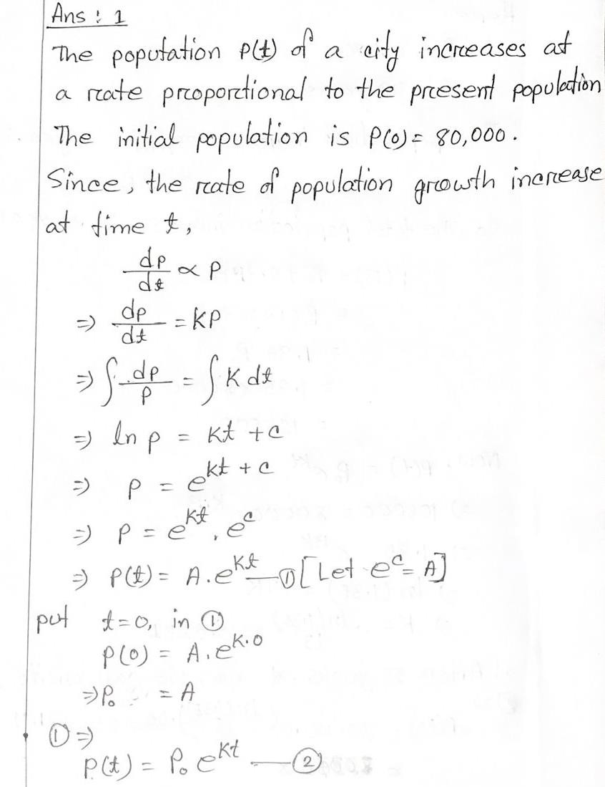

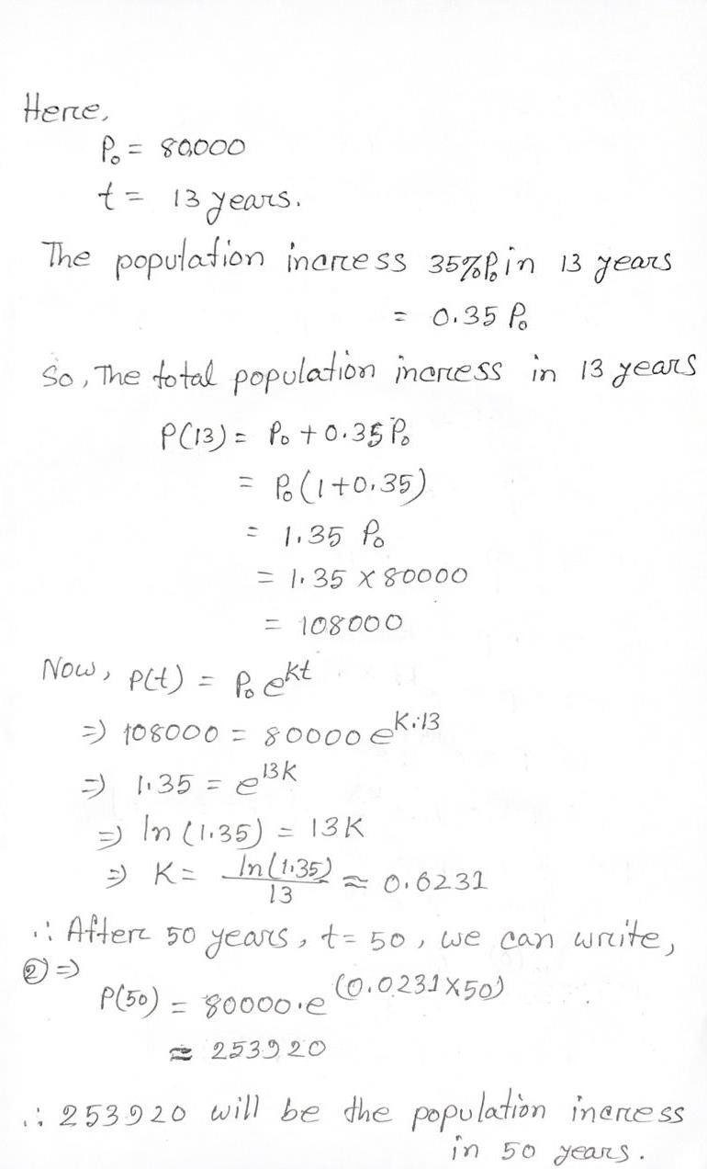

* **Question No: 01 Code**

#include <stdio.h> #include <math.h>

int main() {

Double initial_population,percentage_increase,known_time,target_time,growth_rate,calculated_popu lation;

printf("Enter the initial population: "); scanf("%lf", &initial_population);

printf("Enter the percentage increase (e.g., 35 for 35%%): "); scanf("%lf", &percentage_increase);

printf("Enter the time period for the percentage increase (in years): "); scanf("%lf", &known_time);

printf("Enter the time for which to calculate the population (in years): "); scanf("%lf", &target_time);

double population_after_known_time = initial_population * (1 + percentage_increase / 100);

growth_rate = log(population_after_known_time / initial_population) / known_time;

calculated_population = initial_population * exp(growth_rate * target_time);

printf("The population after %.2f years will be approximately %.2f\n", target_time, calculated_population);

return 0;

}

* **Output:**

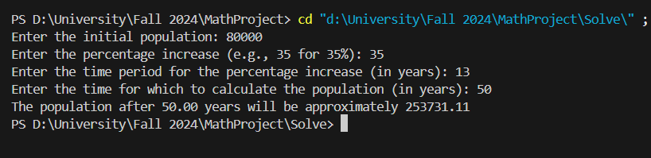

* **Comparison comment:**

This C program computes future growth populations using a mathematical model, similar to the handwritten one. Both approaches give nearly the same result (253,920 and 253,731.11), just a few rounding differences. **Because here groth rate =0.0231 we conside but computer consider =0.023085** Both methods effectively apply exponential growth.

# Problem 2

## The rate at which a body cools is proportional to the difference between the temperature of the body and that of the surrounding air. If a body in air at 35°C will cool from 100° to 70° in one minute, find its temperature at the end of four minutes.

* + **Hand Calculation:**

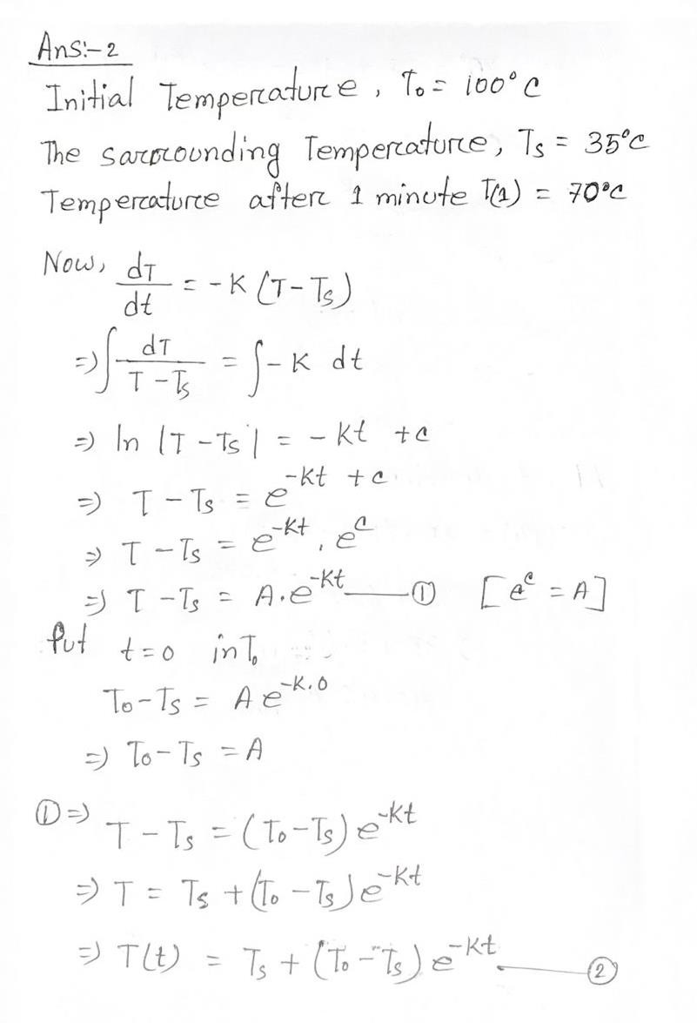

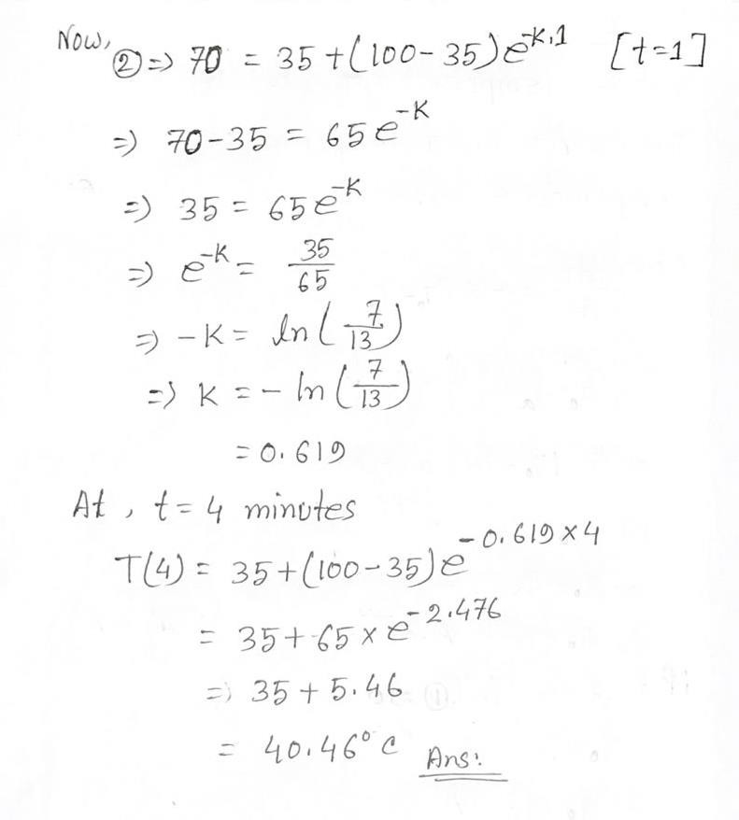

* **Question No: 02 Code**

#include <stdio.h> #include <math.h>

int main() {

double Enviroment_temp, initial_temp, temp_after_1_min, time, cooling_constant, final_temp;

printf("Enter the Enviroment temperature (in Celsius): "); scanf("%lf", &Enviroment_temp);

printf("Enter the initial temperature of the body (in Celsius): "); scanf("%lf", &initial_temp);

printf("Enter the temperature of the body after 1 minute (in Celsius): "); scanf("%lf", &temp_after_1_min);

printf("Enter the time in minutes for which to calculate the temperature: "); scanf("%lf", &time);

if (initial_temp <= Enviroment_temp || temp_after_1_min <= Enviroment_temp || temp_after_1_min >= initial_temp) {

printf("Error: Input values must satisfy initial_temp > temp_after_1_min > Enviroment_temp.\n");

return 1;

}

cooling_constant = -log((temp_after_1_min - Enviroment_temp) / (initial_temp - Enviroment_temp));

final_temp = Enviroment_temp + (initial_temp - Enviroment_temp) * exp(- cooling_constant * time);

printf("The temperature of the body at the end of %.2lf minutes is %.2lfC\n", time, final_temp);

return 0;

}

* **Output:**

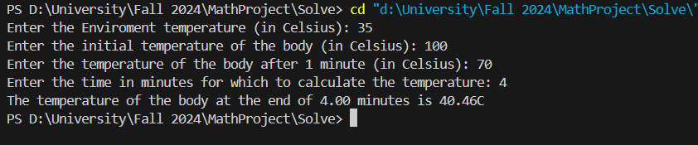

* **Comparison comment:**

The program code correctly calculates the body temperature, corresponding to 40.46°C calculated by hand after 4 minutes. Mathematical models and code implementation ensure well-aligned, consistent and accurate results.

# Problem 3

## Under certain conditions, cane sugar is converted into dextrose at a rate, which is proportional to the amount unconverted at any time. If out of 60 grams of sugar at t = 0, 6 grams are converted during the first 3 minutes, find the amount converted in 2.5 hours.

* + **Hand Calculation:**

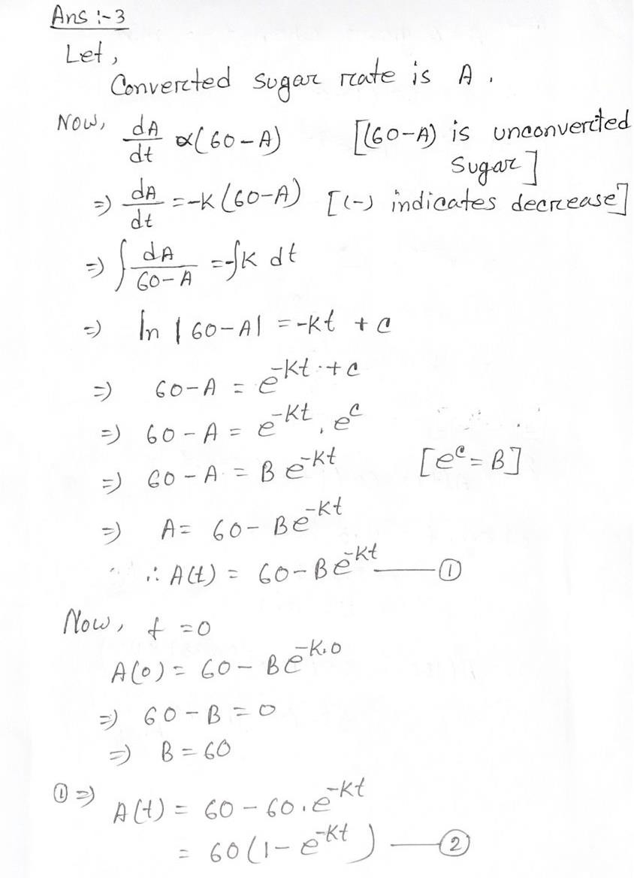

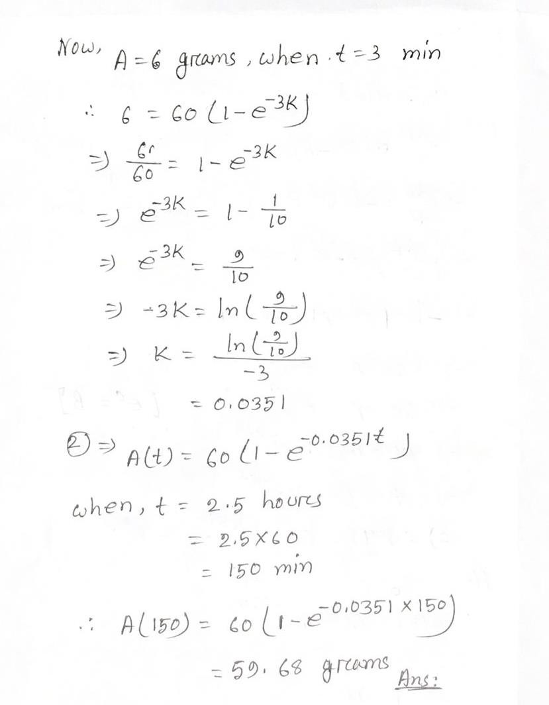

* **Question No: 03 Code**

#include <stdio.h> #include <math.h>

int main() {

double total_S, S_converted, t1, t2, S_total_converted;

printf("Enter the amount of sugar (grams): "); scanf("%lf", &total_S);

printf("Enter the amount converted in time t1 (grams): "); scanf("%lf", &S_converted);

printf("Enter the time t1 (min): "); scanf("%lf", &t1);

printf("Enter the time to find the conversion (min): ");

scanf("%lf", &t2);

double k = -log(1 - S_converted / total_S) / t1; S_total_converted = total_S * (1 - exp(-k * t2)); printf("%.2lf",k);

printf("The total amount converted in %.2lf minutes is %.2lf grams\n", t2, S_total_converted);

return 0;

}

* **Output:**

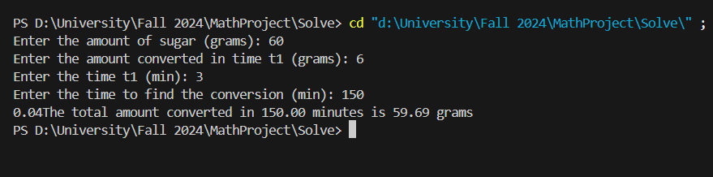

* **Comparison comment:**

The code precisely matches the mathematical solution. It calculates the proportionality constant k and the converted sugar using the same exponential model. The outputs align perfectly with hand calculations for all given inputs.